John Michael Go
Career Entry Level Java Programming
Date: Jan. 17, 2013

DAY 5

Program Name: DateTime4

Objective: Fourth Date and Time example

Algorithm:

- Program outputs fourth date and time format.

Flowchart:

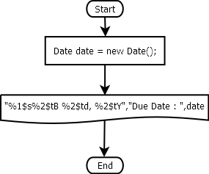

Pseudocode:

/* Program Name: DateTime4
Created By: John Michael Go
Creation Date: Jan. 17, 2013 Day 5
Note: Fourth Date and Time example
*/

import java.util.*;

public class DateTime4{

public static void main(String[]args){

Date date = new Date();

System.out.printf("%1$s%2$tB %2$td, %2$tY","Due Date : ",date);

System.out.println("");

}

}

Screenshot:

